Experiment No.:9 Date: / /

4-Bit Shift Register
AIM: Write a VHDL code for 4-bit shift register using structural style of modeling.

EQUIPMENTS & COMPONENTS:
- Xilinx Vivado 14.5 Software/ Modelsim Student Edition
INTRODUCTION:
Shift registers are essential components in digital circuits used for data storage, manipulation, and transfer. One common type of shift register is the Serial-In Parallel-Out (SIPO) shift register. The SIPO shift register enables serial data input and parallel data output, making it useful for various applications, such as data buffering, data acquisition, and control systems. In this article, we will delve into the working principle of a SIPO shift register, explore its features, and discuss some of its applications.
A Serial-In Parallel-Out shift register is a sequential logic device that can store and shift data bits. It consists of a chain of flip-flops connected in series, with data input and output terminals. The data is shifted from one flip-flop to the next, either in a serial or parallel fashion, depending on the mode of operation.

Key Terminologies of SIPO Shift Registers
- Shift Register: A sequential logic device that stores and shifts data bits. It consists of a chain of flip-flops connected in series.
- Serial Input (SI): The input line through which data is entered into the shift registers one bit at a time.
- Parallel Output: The output lines through which the stored data in the shift register is accessed simultaneously, with each output line corresponding to a flip-flop in the register.
- Clock Signal (CLK): The timing signal that controls the shifting of data within the shift register. The rising or falling edge of the clock signal triggers the transfer of data from one flip-flop to the next.
- Shift Mode: The mode of operation in which the data bits are serially shifted through the flip-flops, with the new data bit entering the first flip-flop, while the existing data bits shift to subsequent flip-flops.
- Parallel Load Mode: The mode of operation in which the shift register holds the data in a fixed state, allowing parallel loading of data. The data bits are directly applied to the parallel inputs of each flip-flop.
- Flip-Flop: A fundamental building block of a shift register that stores a single bit of data. It can be in one of two stable states (0 or 1) and can retain its state until changed by an input signal.
- Data Buffering: The process of using a shift register as a temporary storage buffer for data transfer between different devices operating at different speeds.
- Address Decoding: The use of a SIPO shift register for selecting specific memory locations or devices based on their addresses, allowing efficient data retrieval or storage.
- Control Systems: The application of shift registers in control systems for storing and shifting control signals, enabling sequential operations and timing synchronization.
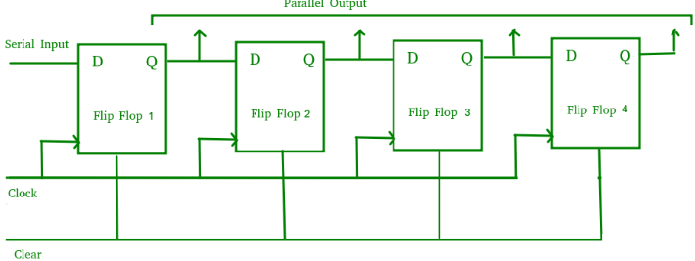
- Serial Input: Serial input (SI) is the entry point for the data into the shift register. The data bits are fed into the first flip-flop in the register. On each clock pulse, the data bit at the serial input is transferred to the first flip-flop and the existing data in the register shifts by one position.
- Parallel Outputs: The parallel outputs (Q0, Q1, Q2, etc.) provide access to the stored data in the shift register. Each flip-flop’s output is connected to a separate output line, enabling simultaneous access to the stored data bits.
- Clock Signal: The clock signal (CLK) synchronizes the shifting of data within the shift register. Typically, the clock edge triggers the transfer of data from one flip-flop to the next. The rising or falling edge of the clock signal can be used, depending on the specific implementation and requirements.
Example:
- We have a 4-bit SIPO shift register with serial input and parallel outputs. The initial state of the register is 0000, and we want to perform a serial data input of 1011. Assume that the clock signal is rising-edge triggered.
- Solution:
- Step 1: Initialize the SIPO shift register with the initial state 0000.
- Step 2: Apply the serial input data (1011) to the serial input (SI) of the shift register.
- Step 3: Activate the clock signal (CLK) with rising-edge triggering.
- Step 4: On the first clock pulse, the first bit of the serial input (1) enters the first flip-flop and the existing data in the register shifts by one position. The state of the shift register after the first clock pulse is 0001.
- Step 5: On the second clock pulse, the second bit of the serial input (0) enters the first flip-flop and the existing data in the register shifts by one position. The state of the shift register after the second clock pulse is 0010.
- Step 6: On the third clock pulse, the third bit of the serial input (1) enters the first flip-flop and the existing data in the register shifts by one position. The state of the shift register after the third clock pulse is 0101.
- Step 7: On the fourth clock pulse, the fourth bit of the serial input (1) enters the first flip-flop and the existing data in the register shifts by one position. The state of the shift register after the fourth clock pulse is 1011.
- Step 8: The final state of the shift register after all four clock pulses is 1011.

VHDL Code using behavioral modeling style:
library ieee;
use ieee.std_logic_1164.all;

entity sipo is

port(
clk, clear : in std_logic;

Input_Data: in std_logic;
Q: out std_logic_vector(3 downto 0) );

end sipo;

architecture arch of sipo is

begin

process (clk)
begin

if clear = '1' then
Q <= "0000";

elsif (CLK'event and CLK='1') then
Q(3 downto 1) <= Q(2 downto 0);

Q(0) <= Input_Data;
end if;

end process;
end arch;

VHDL Code using Structural modeling style:

Shift register:
library IEEE;
use IEEE.STD_LOGIC_1164.ALL;
entity ShiftRegister is
Port ( D : in STD_LOGIC;
CLK : in STD_LOGIC;
Q : out STD_LOGIC_VECTOR (3 downto 0));
end ShiftRegister;
architecture Structural of ShiftRegister is
-- Signal declarations to connect the DFFs
signal Q0, Q1, Q2, Q3 : STD_LOGIC;

component DFF
Port ( D : in STD_LOGIC;
CLK : in STD_LOGIC;
Q : out STD_LOGIC);
end component;
begin
-- First DFF
DFF0: DFF Port Map (
D => D,
CLK => CLK,
Q => Q0
);
-- Second DFF
DFF1: DFF Port Map (
D => Q0,
CLK => CLK,
Q => Q1
);
-- Third DFF
DFF2: DFF Port Map (
D => Q1,
CLK => CLK,
Q => Q2
);
-- Fourth DFF
DFF3: DFF Port Map (
D => Q2,
CLK => CLK,
Q => Q3
);
-- Assign outputs
Q <= Q3 & Q2 & Q1 & Q0;

end Structural;

D Flip flop:
library IEEE;
use IEEE.STD_LOGIC_1164.ALL;
entity DFF is
Port ( D : in STD_LOGIC;
CLK : in STD_LOGIC;
Q : out STD_LOGIC);
end DFF;
architecture Behavioral of DFF is
begin
process(CLK)
begin
if rising_edge(CLK) then
Q <= D;
end if;
end process;
end Behavioral;

Simulation Result of 4-bit Shift Register:
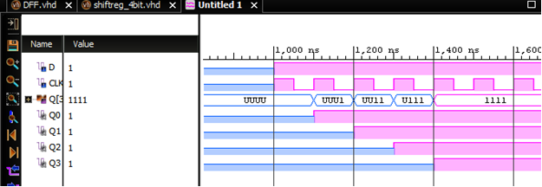

RTL Schematic of 4-bit Shift Register:
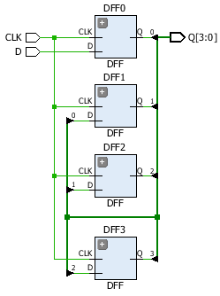
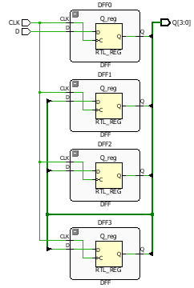

CONCLUSION: 4-Bit shift register has been studied. VHDL code for the same is written and functionality is verified with the help of Xilinx Vivado 14.5 Software.

